**Manual for the**

**Esla Virtual Mapping Project**

A collaboration between Cardiff University, Earth and Ocean Science, and The University of Oviedo, Department of Geology

# Contents

Contents 2

1. Aim: 3

2. Objectives: 3

3. Module Design 3

4. Before you Begin: 3

5. Resources Provided: 4

6. To be completed: 4

7. General Instructions 4

8. Specific Exercises 5

8.1 Constructing a form line and fault map 5

8.2 Determining the strike and dip by structure contours (Locality 1.2) 6

8.3 Determining the dip direction by the rule of Vs (Locality 1.3, others) 7

8.4 Creating a lithostratigraphic Column (daily task) 8

8.5 Analysis of Structural Data 8

8.6 Cross section instructions 8

9. Additional Resources 9

Itineraries have links to outcrop descriptions and photographs

# Aim:

To learn a subset of geological mapping skills using digital resources, including:

* + Recording the rock record in a field notebook
  + Using observations from sedimentary rocks to interpret sedimentary processes and depositional environments
  + Synthesis of field data and interpretations of stratigraphic relationships and structures to establish the geological history of an area
  + Analysis of structural data in deformed rocks
  + Making a geological map, constructing geological cross-sections and a lithostratigraphical column to interpret the geological history of an area

# 2. Objectives:

To produce a geological map of the Cistierna area

To make inferences about sedimentary processes, depositional environments and rock ages from observations of sedimentary rocks and fossils

To produce a stratigraphic column to scale

To produce and interpret stereoplots

To construct two cross-sections of the Cisierna area

To keep a “Field notebook” to record observations, interpretations and the progression of ideas towards completion of the map.

To make a summary of the geological history

# Module Design

The module uses daily itineraries in Google Earth to build up a map by inference from outcrop observations, including rock types, sedimentary structures, fossils and tectonic structures. This follows quite closely the actual field experience of making a map. The major elements of the map will be saved in Google Earth, but the final map will be drawn in hard copy, along with a stereoplot and cross section. A digital field notebook will serve to record data, observations and inferences. Some data and observations will be given: others can be worked out, for example by using structure contours to obtain dips. Field notebooks should be used to make sketches from Google Earth and from detailed photographs, to keep a record of the emerging stratigraphy and structure. Sketches can be added to the field notebook either by using a drawing program or by photographing/scanning hard copies. The most important role of the field notebook will be to record the thought processes that go into building the map. A lithostratigraphic column can be drafted by hand or drawing program. The exercise is designed to be completed in 5 days of 8 hours each.

# Before you Begin:

1. You need a computer with Google Earth Pro installed, a good internet connection and a comfortable working environment, so that you can spend days working on the map. The set-up must be capable of operating Google Earth smoothly.
2. You need to be familiar with the basic Google Earth controls AND:

* Drawing, editing, and saving a path
* Inserting, editing a saving a waypoint
* Using the R keyboard shortcut to return the view to vertically downwards, North at Top
* Holding the shift key to allow more precise orientation of the view while moving the mouse/trackpad

1. Make sure that you read these instructions to the end.

# Resources Provided:

* Instructions (this file) with details of specific and general tasks.
* Daily itineraries for Google Earth with outcrop data and observations.
* Contours at 5 m intervals
* Fossil guide

All of these to be downloaded from the Learning Central module site.

* Hard copy map
* Hard copy stereonet
* Graph paper
* Tracing paper, pin

These will need to be sent, and/or instructions given to them for printing

# To be completed:

* Digital map: form lines, faults, geological boundaries and coloured outcrops
* Hard copy map: outcrops, geological boundaries, strike/dip symbols, annotations
* Hard copy Cross section
* Hard copy Stereoplot
* Hard copy or digital Lithostratigraphic column
* Digital Field Notebook

All hard copies to be scanned/photographed and uploaded via Turnitin if assessment is required

# General Instructions

1. Download kmz files for topographic contours and daily itineraries with data and observations. Open in Google Earth.
2. At each locality, transfer the supplied information into the field notebook, arranged into separate data, observations and inference sections.
3. Add any additional observations and sketches from Google Earth, and your own interpretations.
4. Identify any sedimentary and tectonic structures, and fossils, in the field notebook.
5. Change the colour of the pin to the designated lithological unit.
6. Add extra pins for inferred outcrops of rock types
7. At the end of each day, sketch a provisional stratigraphy in your field notebook (see below)
8. Digitise provisional geological boundaries (these can be changed later)
9. Add appropriate colours to the outcrop locations on your hard copy map
10. Add strike and dip symbols to the hard copy where structural data is provided

# Specific Exercises

## Constructing a form line and fault map

Use the path tool to digitise the boundary of a distinct layer. Save each form line as a separate path (Fig. 1). Do not extrapolate where you cannot see the layer.

1. Where you can clearly see layering that is cut and/or displaced, digitise paths and save them in a different colour (red) for faults.

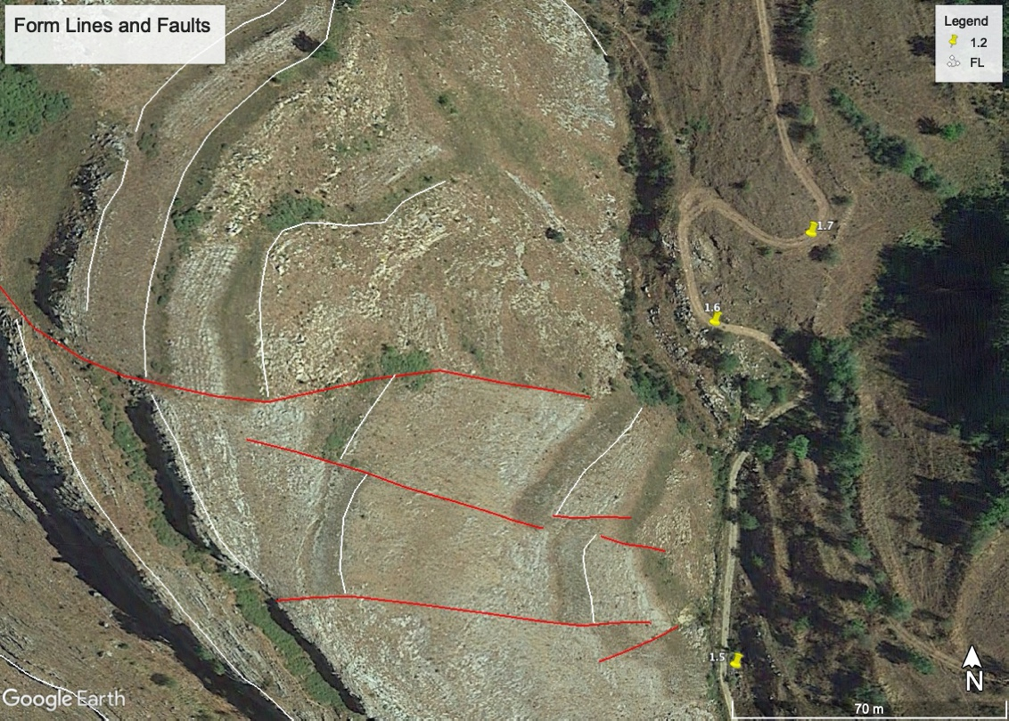

Fig. 1. Form Lines and Faults

1. Place all your form lines in one folder and your faults in another (Fig. 2)

Fig. 2. Folder structure in Google Earth

## 8.2 Determining the strike and dip by structure contours (Localities 1.2 and 2.15)

1. Draw the boundary of one of the limestone layers as a path around the hill (Fig. 3).
2. Construct a structure contour (Fig. 3).
3. Measure the strike using the ruler tool (Fig. 3)
4. Construct a second structure contour at a different elevation
5. Measure the distance along the ground between them, using the ruler tool.

Fig. 3. Structure contours

1. Solve for the dip using the sin rule. Your ruler measurement is the hypotenuse of a right angled triangle: the elevation difference between the two structure contours is the other side of the triangle.
2. Make sketches of these steps in your field notebook and record the result there.

Do this in a few other places on the map.

## 8.3 Determining the dip direction by the rule of Vs (Locality 1.3, others)

There are several places on the map where you can trace a form line across a valley and use the rule of Vs to determine the dip direction (Fig. 4). In Fig. 4, you can determine the dip direction at locality 1.3 and confirm it at one other location in the figure. Make sure that you are viewing the map from vertically above the locality (cmd-R).

Fig. 4. Determining the dip direction from the rule of Vs. Use the white from line to observe a V shape where it crosses a gully at locality 1.3. The dip direction is NE. Can you confirm that at one other point in this view?

Perform this task wherever you can on the map and record the results in your field notebook.

## Creating sketches from Panoramic views

On some localities (e.g. 1.1, 2.9), panoramic views of the field area are provided. You should analyse them carefully and draw a geological sketch highlighting the most important features that you can recognise on them.

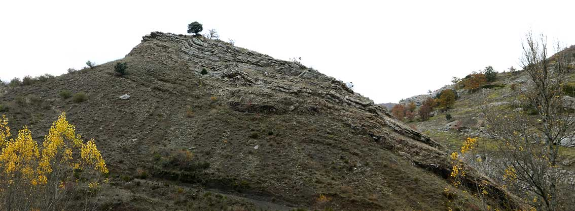

Fig. 5. Example of one of the provided panoramic views.

## Creating a lithostratigraphic Column (daily task)

At the end of each day, in your field notebook, you should try to define the units that you will map, their relative ages and if possible their absolute age from fossil evidence. Do this by making a sketch lithostratigraphic column with the oldest rocks at the bottom.

Here is a hypothetical example of a lithostratigraphic column after one day of mapping:

Fig. 6. Provisional stratigraphic column after one day of mapping

As you gain confidence, you can start to estimate thicknesses of the units.

## Analysis of Structural Data

1. Compile all of your structural data into a spreadsheet with columns for Easting, Northing, structure (bedding, fault plane etc.), Strike, Dip, Trend, Plunge, comments
2. Create a stereoplot for the bedding measurements by hand. If you are confident using a plotting program, you may also use one but be sure that the output is the same as your hand drawn plot.
3. Use the plot to define the fold hinge, and measure its trend and plunge.
4. Write a one paragraph summary of i) what the stereoplot shows ii) what the stereoplot means on the stereoplot itself.

## Cross section instructions

1. Choose two lines to draw cross sections perpendicular to strike in the north and south halves of the map.
2. Draw lines of section on your hard copy map
3. Draw a topographic profile on the graph paper. Make sure that the vertical scale is equal to the horizontal scale.
4. Mark geological boundaries
5. Mark dips and calculate apparent dips
6. Complete geological boundaries according to the dips observed along the section. Use dashed lines to extrapolate boundaries into the air.

# Additional Resources

Road cut itineraries for type sections of lithostratigraphic units

S2K: spreadsheet for plotting structural data in Google Earth